Video-on-Demand
Technologies, Systems, and Applications
Jack Yiu-bun Lee
Department of Information Engineering
The Chinese University of Hong Kong

Preface Jack Y.B. Lee
- Target Audience  Assumes engineering background;  No prior knowledge on multimedia and video
technologies required.
- Workshop Outline  Part 1: Concepts  Part 2: Technologies  Part 3: Systems  Part 4: Applications
2
Table of Contents
- CONCEPTS  - What is Video-on-Demand (VoD)?  - Types of Video Services  - Major Challenges  - TECHNOLOGIES  - AV Signal Processing  - Continuous Media  - Coding and Compression  - Storage  - Network  - SYSTEMS  - Service Model  - Video Retrieval  - Admission Control  - I/O Bandwidth  - Storage Capacity  - Video Delivery  Video-on-Demand - Technologies, Systems, and Applications | 5  6  12  17  18  19 24  32  45  52  91 92 95  105  107 112  116  3
Table of Contents | Jack Y.B. Lee
4. APPLICATIONS | 127
4.1 Entertainment | 128
4.2 Education and Training | 129
4.3 Video Library | 131
4.4 Networked Video Kioks | 132
4.5 Online Commerce | 134
5. SUMMARY | 135
6. REFERENCES | 136
4
Part 1 - Concepts
- Contents
    - 1.1 What is Video-on-Demand (VoD)?
    - 1.2 Types of Video Services  1.3 Major Challenges
Video-on-Demand - Technologies, Systems, and Applications | 5
1.1 What is Video-on-Demand (VoD)? | Jack Y.B. Lee
- General System Overview
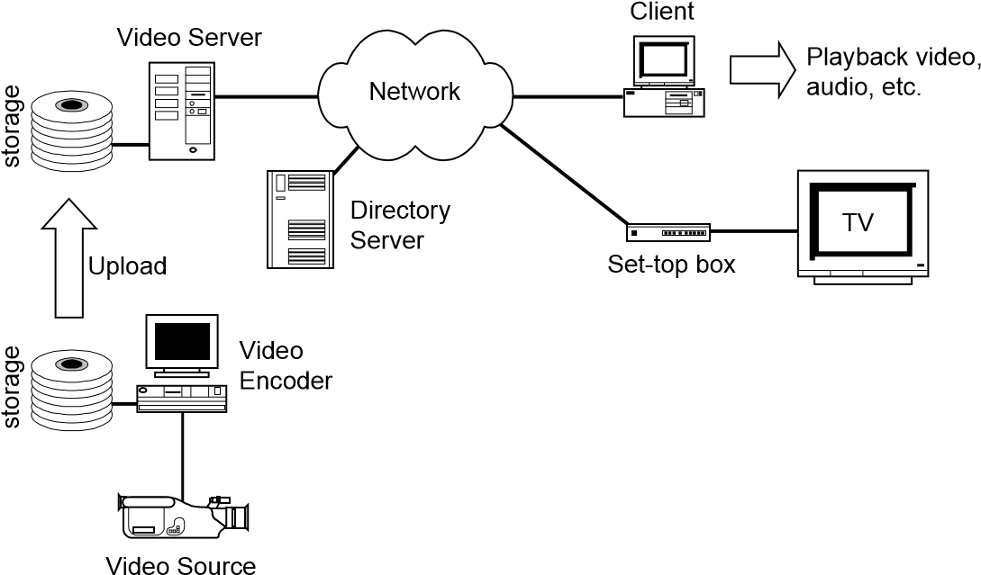
6

- How is it different from traditional data servers?  The Download Model:
Data Server Data Client User
Push Button
Request
Send data
Present data
View data
Wait
Video-on-Demand - Technologies, Systems, and Applications 7
1.1 What is Video-on-Demand (VoD)? _{Jack Y.B. Lee}
- How is it different from traditional data servers?
 The Download Model:
- Data Transfer Time T
T= Size of data / link speed
E.g. (a) Download a web page (10KB) through 28.8Kbps modem T = 10*8/28.8 = 2.78 seconds
      - Download a JPEG image (100KB) using 28.8Kbps modem T = 100*8/28.8 = 27.8 seconds
      - Download a one-hour MPEG1 video (540MB) using
28.8Kbps modem:
T = 540*8*1000/28.8 = 41.67 hours!
- The Problem : Too much data, too little bandwidth!
8
- How is it different from traditional data servers?
 The Download Model:
- Why not just use a high-speed network?
– Say, using 10Mbps Ethernet for an 1-hr MPEG1 video:
T = 540*8/10 = 7.2 minutes
Much better, but will you wait 7 minutes to watch a video? How about a full-length movie (2 hours)?
      - So how much bandwidth is needed?
If max waiting time is 10 seconds, then C = 540*8/10 = 432 Mbps
      - Hence simply raising bandwidth is not a good solution.
Video-on-Demand - Technologies, Systems, and Applications 9
1.1 What is Video-on-Demand (VoD)? _{Jack Y.B. Lee}
- How is it different from traditional data servers?  The Streaming Model:
Web Server Web Client User
Push Button
Request
Send data
Present data
View Data
Present data
Present data
Present data
Present data
Wait
10
- Requirement for Streaming  Data must be progressively decodable & presentable
- Example: Video, minimum unit is one frame.
- Counter Example: Program, partial program cannot run.
- Types of Streaming  Realtime
- The data have a pre-determined sequence and time of presentation. For example, video and audio.
 Non-Realtime
• The data does not have presentation time requirement. For example, progressive JPEG.
Video-on-Demand - Technologies, Systems, and Applications 11
1.2 Types of Video Services _{Jack Y.B. Lee}
- Broadcast / Multicast Video:
Video Server
Broadcast
Network
1
2
3
1
2
1
Ch.1
Ch.2
Ch.1
3
Ch.3
One way data flow
Passive receive,
no control except
selecting channels.
One channel is needed per movie / programme.
12

1.2 Types of Video Services
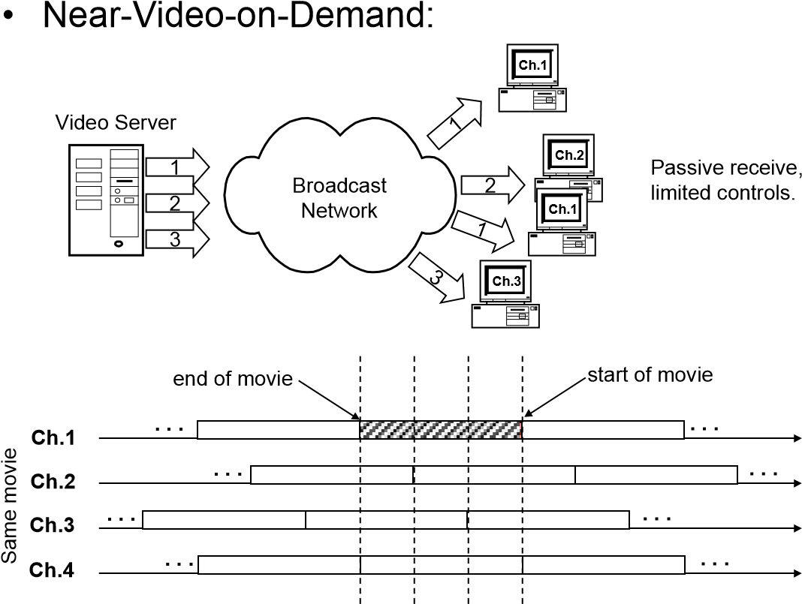
Video-on-Demand - Technologies, Systems, and Applications 13
1.2 Types of Video Services _{Jack Y.B. Lee}
Near-Video-on-Demand:
•
. . .
. . .
. . .
. . .
. . .
. . .
. . .
. . .
Ch.1
Ch.2
Ch.3
Ch.4
start of movie
end of movie
T
Same movie
If movie length is L then number of channels needed per movie is: N = L / T
For example, if L = 120 minutes, T = 10 minutes, then number of video channels needed N = 120 / 10 = 12 channels.
This also means that in the worst case, the user has to wait 10 minutes before viewing a movie.
System response time inversely proportional to number of required channels.
14
1.2 Types of Video Services
- True Video-on-Demand
Video Server
Request
Video Data
Independent channel
- Full interactive controls, like pause/resume, seeking, fast forward, etc.
- One video channel per user required.
Video-on-Demand - Technologies, Systems, and Applications 15
  - Types of Video Services _{Jack Y.B. Lee} • Comparisons:
 | Broadcast Video | Near-Video-on-Demand (Pay-Per-View) | True Video-on-Demand
Select video?  Select time to watch?  Interactive? | Yes, but limited to a few channels  No  No | Yes, but limited to a few programmes  Yes  ( limited to fixed time slots )  None or very little | Yes  Anytime  VCR-like control
# of Viewers | Unlimited | Unlimited | Limited
Cost / Viewer | Low | Medium | High
16
  - Major Challenges
- Volume
 High-quality digital video requires large amount of
capacity in storage and delivery.
- Time Sensitivity  Video data must be delivered and presented according to a stringent timing schedule, otherwise the video playback will not be continuous.
Video Server
Client
Network
storage
Video-on-Demand - Technologies, Systems, and Applications | 17
Part 2 - Technologies  • Contents   2.1 AV Signal Processing  2.2 Continuous Media  2.3 Coding and Compression  2.4 Storage  2.5 Network | Jack Y.B. Lee
18

- Analog and Digital Signals  From the physical world, a sensor transforms the timedependent or space-dependent physical variables into electrical signals.
 For example: recording audio
sound wave
However, digital computer/systems cannot handle analog signals directly.
mic

amp
Video-on-Demand - Technologies, Systems, and Applications 19
2.1 AV Signal Processing _{Jack Y.B. Lee}
- Analog and Digital Signals  We need Analog-to-Digital (A/D) Conversion:
analog scale
x
digital scale
- Use a number to represent a range of values in the analog scale.
- For example, represent 5~10mV as 1, 10~15mV as 2, etc.
20
- Analog-to-Digital (A/D) Conversion  Sampling Accuracy
- The A/D conversion process is also referred to quantization.
- The problem is digital number covers a range of analog values, hence the mapping is not one-to-one.
- For example, a 7.5mV input converted to a digital number of 1 is only an approximation.
- Because another input of say 9.5mV will also be represented by a digital number of 1.

A/D

A/D
7.5
9.5
1
1

D/A

D/A
5
5
Video-on-Demand - Technologies, Systems, and Applications 21
2.1 AV Signal Processing _{Jack Y.B. Lee}
- Analog-to-Digital (A/D) Conversion  Sampling Accuracy
- The amount of digital numbers used is called quantization level, and is usually measured in bits.
- If n bits are used, then there are 2^{n} numbers or levels to represent distinct signal values.
- For example:
– CD-audio uses 16 bits for audio, hence there are a total of 2¹⁶ or 65536 levels.
- A digital signal is usually represented as a binary codeword:
– e.g. 01101001
= (0x2⁷)+(1x2⁶)+(1x2⁵)+(0x2⁴)+(1x2³)+(0x2²)+(0x2¹)+(1x2⁰)
= 0 + 64 + 32 + 0 + 8 + 0 + 0 + 1
= 105
22
- Analog-to-Digital (A/D) Conversion  Sampling Rate
- How often do we take samples of the analog signal and convert it to digital form?
- For example:
      - If we take one sample every second, then the sampling rate is 1Hz.
      - CD audio uses a sampling rate of 44.1kHz.
- How fast should I sample?
      - Nyquist in 1924 showed that if the sampling rate is twice the max. frequency of the signal, than no information will be lost.
      - Hence CD audio's 44.1kHz covers the entire range of human-audible frequencies (20~20kHz).
Video-on-Demand - Technologies, Systems, and Applications 23
2.2 Continuous Media _{Jack Y.B. Lee}
- Digitizing Audio  Data Volume
- Sampling frequency = B Hz
- A/D precision = L bits
- Data rate = L x B bits per second (or bps or b/s)
E.g. CD Audio
•
Fixed interval of 22.7 microseconds
16
bits
( B = 44.1kHz )
      - Data rate R = 44.1 x 16 = 705.6 kbps (mono )
      - Data rate R = 2 x 705.6 = 1411.2kbps (stereo )
Periodic digital signals are also called continuous media or isochronous media.
24

- Digitizing Video  Operation Model
digital video data stream

A/D

A/D

A/D
R
G
B
analogy
digital
encoder
 Primary Colors
• Red-Green-Blue (RGB)
    - Red = 700 nanometers light wave
    - Green = 546 nanometers light wave
    - Blue = 436 nanometers light wave
Video-on-Demand - Technologies, Systems, and Applications 25
2.2 Continuous Media _{Jack Y.B. Lee}
- Digitizing Video  Analog Video Standards
- NTSC (National Television Systems Committee)
– In use in American, Canada, Japan, & Latin America, etc; – Signal Composition:
Y = 0.30R + 0.59G + 0.14B
I = 0.74(R-Y)-0.27(B-Y) = 0.60R + 0.28G + 0.32B Q = 0.48(R-Y)+0.41(B-Y) = 0.21R + 0.52G + 0.31B
    - Interlaced scanning w/ 4:3 aspect ratio;
    - Resolution is 525 lines per frame at 29.97 frames per second (fps).
26
- Digitizing Video  Analog Video Standards
- PAL (Phase Alteration Line)
– In use in Hong Kong, Europe, Australia, etc; – Signal Composition:
Y = 0.30R + 0.59G + 0.11B
U = 0.493(B-Y) = -0.15R - 0.29G + 0.44B V = 0.877(R-Y) = 0.62R + 0.52G + 0.10B
– Interlaced scanning w/ 4:3 aspect ratio; – Resolution is 625 lines per frame at 25 fps.
- Others like SECAM, etc.
Video-on-Demand - Technologies, Systems, and Applications 27
2.2 Continuous Media _{Jack Y.B. Lee}
- Digitizing Video  Digitization Model
. . .
. . .
A Pixel
An Image
or Bitmap
Video:
Frame:
Pixel:
R
G
B
Y
U
V
or
28
- Digitizing Video  Digital Video Standards
- Studio-Quality TV (ITU-R 601)
    - Sampling Rate: Y(13.5Mhz), U (6.75Mhz), V (6.75Mhz);
    - Digitizing NTSC Video Signal
- Raw data rate = (13.5+6.75+6,75) x 8 = 216 Mbps.
- Raw Pixel Resolution = 864 x 525 pixels (removing retrace ,etc.).
- Active Video Area = 720 x 486 pixels.
- Sub-sampling (4:2:2) (reduce bit-rate by 33%) Y (720x486), U (360x486), V (360x486)
- 8- bits per sample per signal channel.
- Net data rate after sub-sampling = 168 Mbps.
– HDTV (US)
- 720,000 pixels per frame
- 24 bits per pixel
- 60 fps
- Data rate = 1.0368 Gbps.
Video-on-Demand - Technologies, Systems, and Applications 29
2.2 Continuous Media _{Jack Y.B. Lee}
- Digitizing Video  Digital Video Standards
- Videoconferencing Quality - CIF
- Common Interchange Format (CIF), (ITU-TS H.261) – Frame size (4:1:1 sub-sampling):
      - 352 x 288 for luminance (Y ) • 176 x 144 for chrominances (U, V )
      - Data rate = 36 Mbps.
      - Videoconferencing Quality - QCIF
- Quarter-Common Interchange Format (QCIF) – Frame size:
    - 176 x 144 for luminance (Y ) • 176 x 144 for chrominances (U, V ) • Data rate = 18 Mbps.
30
    - Digitizing Video  Digital Video Standards
    - Videoconferencing Quality - Super-CIF
- Super-Common Interchange Format (Super-CIF) – Frame size (4:1:1 sub-sampling):
      - 704 x 576 for luminance (Y ) • 352 x 288 for chrominances (U, V )
      - Data rate = 146 Mbps.
      - VCR Quality - SIF
- Standard Interchange Format (Defined in MPEG-1) – Frame size (4:1:1 sub-sampling):
        - 352 x 240 (NTSC) or 352 x 288 (PAL/SECAM) for luminance (Y )
        - 176 x 120 or 144 for chrominances (U, V )
Video-on-Demand - Technologies, Systems, and Applications 31
2.3 Coding and Compression _{Jack Y.B. Lee}
- Motivation
  - Digital audio and video generates vast amount of data that are difficult to process and deliver quickly.
- What is compression?
  - Reduce the number of bits used to encode the same
information by exploiting:
- Spatial redundancy
– Correlation between neighboring pixels
- Spectral redundancy
– Correlation between color components
- Psycho-visual redundancy
– Perceptual properties of the human visual system
32

- Types of compression  Lossless compression
- No information is loss in the encode/decode process.
 Lossy compression
  - Some information is loss in the encode/decode process.
  - A Generic Model for Compression:
Transformer
Quantizer
Encoder
Raw
Image
Transformed image
(
easier to compress
)
Symbols
Binary Bitstream
source coding
entropy coding
Video-on-Demand - Technologies, Systems, and Applications 33
2.3 Coding and Compression _{Jack Y.B. Lee}
- A Generic Model for Compression  Transformer
- A one-to-one mapping to transform the signal from the spatial domain to other domains, which are easier to compress.
- Common transformers
  - Discrete Cosine Transform (DCT)
  - Wavelet Transform  Quantizer
- A many-to-one mapping to reduce the data rate.
- Loss in information is introduced in this stage.
- Encoder
    - Maps symbols generated by Quantizer to bit-strings.
    - Exploits statistical knowledge to reduce bit rate.
34
    - MPEG Compression Standards
- MPEG standards for Motion Picture Expert Group
      - It is a standard for video compression.  Composition
      - MPEG-1
        - VCR-quality video up to 8 Mbps;
        - Used in Video-CD, CD-I and Video-on-Demand systems.
• MPEG-2
        - Broadcast quality video from 3 to >10 Mbps;
        - Used in DVD, HDTV, and Video-on-Demand systems.
• MPEG-3
– Originally slated for HDTV but later dropped due to the incorporation of HDTV into MPEG-2.
• MPEG-4
– Low-bit rate video for video telephony systems.
Video-on-Demand - Technologies, Systems, and Applications 35
2.3 Coding and Compression _{Jack Y.B. Lee}
- MPEG System Structure  Encoding Process:
Audio
Encoder
Video
Encoder
Multiplexer
)
System Encoder
(
Audio
Input
Video
Input
video bit-stream (video packets)
audio bit-stream (audio packets)
System bit-stream
)
system packs
(
Decoding Time Stamp
Presentation Time Stamp
(DTS) Added ( PTS) Added
36
- MPEG System Structure  Bit-stream Structure
- Audio and video are compressed and encoded individually into audio packets and video packets.
- Decoding Time Stamps (DTS) are added to the packets to guide the decoder controller in the decoding process.
- The audio and video packets are then multiplexed into a system stream by a system encoder (or multiplexer).
- Presentation Time Stamps (PTS) are then added to synchronize the audio and video streams.
Video-on-Demand - Technologies, Systems, and Applications 37
2.3 Coding and Compression _{Jack Y.B. Lee}
- MPEG System Structure  Audio Compression
- How does it work?
    - MPEG Audio strips information in the audio signal that is less sensitive to the human perception system (ear).
    - This is called "perceptual coding".
- MPEG Audio Layers
– The Layer I psychoacoustic model only uses frequency masking.
- This means that it strips frequencies that are hidden behind others.
You shouldn't encode at higher compression than 384 Kbps. – Layer II does more filtering.
- In layman's terms, it decides better what information can be stripped. Encoding at 160 Kbps sounds good, at 192 Kbps it becomes difficult to hear the difference, and at 256 Kbps and above produce very good quality audio.
38
- MPEG System Structure  Audio Compression
- MPEG Audio Layers
– Layer III is the most complex MPEG Audio model.
- It does even more filtering than Layer II and uses a Huffman coder. While encoding at 112 Kbps sounds good, 128 Kbps is even closer to the original; at 160 Kbps and 192 Kbps you won't hear a difference to the original.
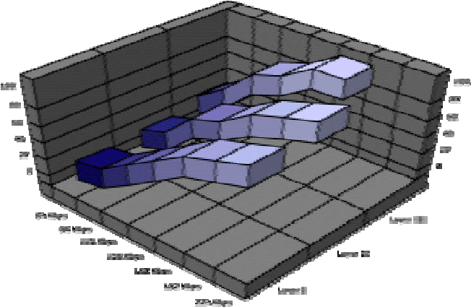
Video-on-Demand - Technologies, Systems, and Applications 39
2.3 Coding and Compression _{Jack Y.B. Lee}
- MPEG System Structure  Video Compression
- Two Basic Compression Techniques:
    - Block-based motion compensation for the reduction of the temporal redundancy, and
    - Transform domain (DCT) coding for the reduction of spatial redundancy.
- Temporal Redundancy Reduction
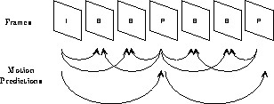
Three types of frames: intra pictures (I frames), predicted pictures (P frames), and bidirectionally interpolated pictures (B frames).
40
- MPEG System Structure  Video Compression
- Temporal Redundancy Reduction
– I frames
- Compressed independently and provide access points for random access, but only with a moderate compression.
– P frames
- Coded with reference to a previous frame, which can be either an I or P frame, with higher compression.
– B frames
- Intended to be compressed with a low bit rate, using both the previous and future references (I, P).
IBBPBBPBBPBBIBBPBBPBBPBBIBBPBBPBBPBBI . . .
A group of picture (GOP)
Video-on-Demand - Technologies, Systems, and Applications 41
2.3 Coding and Compression _{Jack Y.B. Lee}
- MPEG System Structure  Video Compression
- Motion Compensation (Estimation)
    - Each picture is divided into blocks of 16 x 16 pixels, called a macroblock.
    - Each macroblock is predicted from the previous or future frame, by estimating the amount of the motion in the macroblock during the frame time interval.
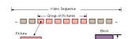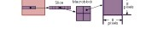
–
This process is very computationally intensive.
42
- MPEG System Structure  Video Compression
- Spatial Redundancy Reduction
– For the reduction of spatial redundancy in each I picture or the prediction error in P and B pictures, the MPEG
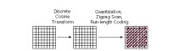
standard uses
•
Discrete cosine transform (DCT)
•
Quantization
•
Run-length encoding
source coding
entropy coding
Video-on-Demand - Technologies, Systems, and Applications 43
2.3 Coding and Compression _{Jack Y.B. Lee}
- Compression and VoD  Two Types Compression
- Constant Bit-Rate (CBR)
    - The bit-rate of the compressed video stream over a short time interval is constant.
    - The video quality is not constant. Loosely speaking, more motions degrade video quality.
    - CBR videos are good for system design but bad for the user.
- Variable Bit-Rate (VBR)
    - The video quality is constant for the entire video stream.
    - The bit-rate is adjusted to maintain a constant video quality.
    - VBR videos are good for the user but bad for system design.
44

•
System Model
- Challenges
 Real-time storage and retrieval:
- Continuous media data must be presented using the same timing sequence with which they were captured.
- Any deviation from this timing sequence can lead to artifacts such as jerkiness in video motion, pops in audio, or possibly complete unintelligibility.
Video-on-Demand - Technologies, Systems, and Applications 45

2.4 Storage Jack Y.B. Lee
- Challenges
 Real-time storage and retrieval:
- Media components may also need synchronization. For example, a video stream must synchronize an audio stream in a movie.  High data transfer rate and large storage space:
- Digital video and audio playback demands a high data transfer rate, so that storage space is rapidly filled.
( E.g. MPEG1 ~ 1.5Mbps, MPEG2 ~ 4Mbps )
- The server must efficiently store, retrieve, and manipulate data in large quantities at high speeds.
46
- Disk Model
Disk Platters / Surface
One disk track
Disk Arm
Servo
 The disk platters spin at speed from 3600rpm to
10000 rpm;  Disk heads in all platters move together.  A disk track is further divided into disk sectors.
Video-on-Demand - Technologies, Systems, and Applications 47

2.4 Storage Jack Y.B. Lee
- Disk Model  Fixed Delays
- Processing delay at disk controller;
- Delay at data bus (e.g. SCSI) between disk and controller;
- Head-switching time;  Variable Delays
- Rotational Latency
  - Depends on position and spindle speed
- Seek time
  - Depends on number of tracks to seek
- Transfer Time
  - Depends on how much data to transfer to host
48
- Disk Model  Disk-Seek Time Function:
n
n
β
α
+
=
)
(
T_{seek}
Number of tracks to seek
Seek-time constant (sec) Fixed overhead (sec)
 Total Disk-Read Time Function:
T_{read} (n) =α+β n+T
disk
latency
R
Q
+
Size of data to read (Bytes)
Disk transfer rate (Bytes/sec)
Rotational latency (sec)
 | Video-on-Demand - Technologies, Systems, and Applications |  |  | 49
 | 2.4 Storage  • Typical Disk Parameters  Seagate 4GB ST12400N (SCSI-2) |  |  | Jack Y.B. Lee
Disk Parameter |  | Value
Spindle speed |  | 5411 rpm
Max latency (r) |  | 11 ms
Number of tracks |  | 2621
Raw transfer rate |  | 3.35 MB/s
Single-track seek |  | 1 ms
Max full-stroke seek |  | 19 ms
50
- Typical Disk Parameters  SCSI Variants
Types | Variants | Max. Speed | Number of Devices | Max. Cable Length
SCSI-1 | - | 5 MB/s | 8 | 6 m
SCSI-2 | Fast SCSI | 10 MB/s | 8 | 1.5 m~3m
 | Fast Wide SCSI | 20 MB/s | 16 | 1.5 m~3m
SCSI-3 | Ultra SCSI | 20 MB/s | 8 | 1.5 m
 | Wide Ultra SCSI | 40 MB/s | 16 | 1.5 m
 | Ultra2 SCSI | 40 MB/s | 8 | 12 m
 | Wide Ultra2 SCSI | 80 MB/s | 16 | 12 m
 | Ultra3 SCSI | 80 MB/s | 8 | 12 m
 | Wide Ultra3 SCSI | 160 MB/s | 16 | 12 m
Fibre Channel | FC-AL | 100~200MB/s | 126 | 30 m~10km
- Note that the "Max. Speed" is the top speed of the interface.
- The actual achievable speed depends on the performance of the connected disks.
Video-on-Demand - Technologies, Systems, and Applications 51

2.5 Network Jack Y.B. Lee
- Basic Concepts
 Classification by Transmission Technology:
- Broadcast networks
- Point-to-point networks  Broadcast Networks
- A single communication channel is shared by all hosts.
- A host sends packets on the channel, which are then received by all hosts. An address field within a packet is used to identify the intended receiver.
- Special addresses: Broadcast address & multicast address
52

2.5 Network
- Basic Concepts
 Point-to-Point Networks
- Each communication channel links up two hosts.
- To go from one host to another, intermediate hosts may need to be traversed (routing).
A
B
D
C
E
F
Video-on-Demand - Technologies, Systems, and Applications 53

2.5 Network Jack Y.B. Lee
- Basic Concepts
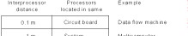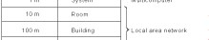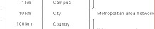
⬥
Classification by Scale or Distance
54
2.5 Network
- Basic Concepts  Local Area Networks (LANs)
- Restricted in size (up to one km)
- Mostly are broadcast networks
- Speeds range from 10Mbps to 100Mbps
- Low error rate
- Low latency
c:\>ping adnetpc0.ie.cuhk.edu.hk
Pinging adnetpc0.ie.cuhk.edu.hk [137.189.97.120] with 32 bytes of data:
Reply from 137.189.97.120: bytes=32 time<10ms TTL=128
Reply from 137.189.97.120: bytes=32 time<10ms TTL=128
Reply from 137.189.97.120: bytes=32 time<10ms TTL=128
Reply from 137.189.97.120: bytes=32 time<10ms TTL=128
Video-on-Demand - Technologies, Systems, and Applications 55

2.5 Network Jack Y.B. Lee
- Basic Concepts  Wide Area Networks (WANs)
- Spans large geographical area (country or continent).
- Connects subnets in a local area (LAN).
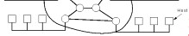
56
- The IEEE 802 Series Standards
- IEEE 802.1 - Introduction to the 802 series standards;  IEEE 802.2 - Logical Link Control (LLC) Protocol  IEEE 802.3 - CSMA/CD (Ethernet)  IEEE 802.4 - Token Bus  IEEE 802.5 - Token Ring
- IEEE 802.6 - Distributed Queue Dual Bus (MAN)
- Others
 FDDI (Fiber Distributed Data Interface)  ATM (Asynchronous Transfer Mode)
Video-on-Demand - Technologies, Systems, and Applications 57
2.5 Network - Hardware _{Jack Y.B. Lee}
- Ethernet (IEEE 802.3)  Broadcast Physical Network (CSMA/CD)  Maximum end-to-end distance is 2500 meters
 Speed is 10Mbps shared by all stations on the network  Cabling
58

- Ethernet (IEEE 802.3)  Switched Ethernet
- A 802.3 LAN will eventually saturate when more and more stations are added.
- To increase capacity, one may upgrade to higher data rate such as 100Mbps or even 1Gbps.
This approach is expensive because all network cards and associated equipment have to be upgraded ( replaced ).
- The Solution is Switched LANs!
Video-on-Demand - Technologies, Systems, and Applications 59
2.5 Network - Hardware _{Jack Y.B. Lee}
- Ethernet (IEEE 802.3)  Switched Ethernet
Backplane Switch
)
Commonly >1Gbps
(
Collision
Domain
Collision
Domain
Collision
Domain
Collision
Domain
Station 1
Station 2
Station 3
Station 4
Station 5
Station 6
Station 7
Station 8
Station 9
Station 10
LAN Switch
60
- Ethernet (IEEE 802.3)  Good
- Most popular
- Shortest delay at low load
- Simple protocol, passive cable
- Bad
    - Substantial analog operation (carrier sense, collision detection)
    - Frame size must be at least 64 bytes
    - Non-deterministic delay (due to collision)
    - No priorities
    - Cable length limited to 2.5km at 10Mbps
    - Performance deterioates at high load
Video-on-Demand - Technologies, Systems, and Applications | 61
2.5 Network - Hardware  - Token Ring (IEEE 802.5)  History  - Proposed by IBM  - Targeted at business networks  Physical Layer  - Cabling: Shielded twisted pairs  - Data Rate: 1, 4, or 16Mbps   MAC Sublayer  • Token passing, collision free. | Jack Y.B. Lee
62
    - Token Ring (IEEE 802.5)
- Data bits circulate around the token ring in one direction.
Let data rate be R Mbps, then 1 bit is emitted every 1/R µsec. With signal propagation speed of 200m/µsec, each bit occupies 200/R meters on the ring.
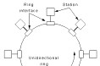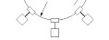
Video-on-Demand - Technologies, Systems, and Applications 63
2.5 Network - Hardware _{Jack Y.B. Lee}
- Token Ring (IEEE 802.5)  Good
- Fewer analog components
- Supports any cabling
- Resilience to cable failures (through the use of wire center)
- Supports priorities
- Excellent throughput and efficiency at high load
 Bad
  - Substantial delay at low load (due to token passing)
  - Malfunction monitor station can bring down the ring
  - Less popular
64

2.5 Network - Software
- Protocol Hierarchies  Network systems are broken down into multiple layers.  Each layer offers a well-defined interface to provide services to the upper layers.
 A protocol is defined at each layer for exchanging
information between two peers.
Video-on-Demand - Technologies, Systems, and Applications 65
2.5 Network - Software Jack Y.B. Lee
- Protocol Hierarchies  An example protocol hierarchy:
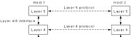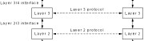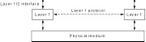
66
2.5 Network - Software
- Protocol Processing  Headers are added and removed  A message may be broken down into multiple
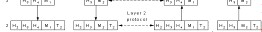
Video-on-Demand - Technologies, Systems, and Applications
67
segments
2.5 Network - Software _{Jack Y.B. Lee}
- Protocol Software
 A protocol layer provides services to upper layers.  Types of Services
- Connection-Oriented versus Connectionless Services
      - Connection setup required?
      - Analogy: Telephone versus Postal Mail
- Reliable versus Unreliable Services
– Automatic recover from errors?
- Stream versus Message Services – Preserve message boundary?
68
- What?
 A reference model is an architecture for layered
network communications.
- The OSI Reference Model
    - Developed by the International Standards Organization ( ISO ).
    - The model is called Open Systems Interconnection ( OSI ).  Consists of seven layers.
Video-on-Demand - Technologies, Systems, and Applications 69
2.5 Network - Reference Models Jack Y.B. Lee
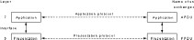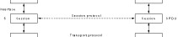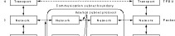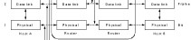
•
The OSI Reference Model
70

- The OSI Reference Model  Physical Layer
- Concerns transmitting raw bits (0 and 1) over a physical communication channel (copper wire, fibre optic cable, wireless media).  Data Link Layer
- Provides a service which is free of undetected transmission errors.
- Optionally provides error control and flow control.
- Coordinating transmissions and receptions on the same link.
- Resolve contentions in broadcast networks.
Video-on-Demand - Technologies, Systems, and Applications 71
2.5 Network - Reference Models _{Jack Y.B. Lee}
- The OSI Reference Model  The Network Layer
- Concerned with controlling the operation of the subnet. • Handles routing of a packet from source to destination.
- Handles congestions.
- Keeps accounting information if needed.
- Converts between incompatible addressing schemes and packet formats.  The Transport Layer
- Provides an error-free connection on an end-to-end basis.
( Unreliable messages service is also possible. )
- Handles upward and downward multiplexing.
- Handles name resolution across the entire network.
- Handles flow control between sender and receiver.
72
- The OSI Reference Model  The Session Layer
- Provides session management
      - dialogue control
      - token management
      - synchronization or crash recovery
 The Presentation Layer
  - Concerns the syntax and semantics of the information transmitted
  - Performs information encoding and decoding to facilitate the exchange of information
    - Text: ASCII versus Unicode
    - Numbers: byte ordering and byte size differences
Video-on-Demand - Technologies, Systems, and Applications 73
2.5 Network - Reference Models _{Jack Y.B. Lee}
- The OSI Reference Model  The Application Layer
- Defines the protocols and services for a specific application.
- Examples:
    - File Transfer (FTP)
    - Email (SMTP, POP3)
    - WWW (HTTP)
    - Network News (NNTP)
    - Video Streaming Protocols
74
- The TCP/IP Reference Model
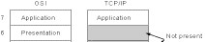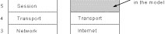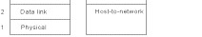
Not defined
in the model
These are reference models.
Video-on-Demand - Technologies, Systems, and Applications 75
2.5 Network - Reference Models _{Jack Y.B. Lee}
- The TCP/IP Reference Model  Protocols and Networks
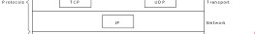
This is a protocol stack conforming to the TCP/IP reference model.
76
- The TCP/IP Reference Model  The Internet Layer
- Protocol used: Internet Protocol (IP)
- Assumes a packet-switching network
- Connectionless
- Handles routing of IP packets
- Handles congestion
- Similar to OSI’s network layer
Video-on-Demand - Technologies, Systems, and Applications 77
2.5 Network - Reference Models _{Jack Y.B. Lee}
- The TCP/IP Reference Model  The Transport Layer
- Protocol one: Transmission Control Protocol (TCP)
    - Provides a reliable, connection-oriented, stream service.
    - Handles data packetization and reassembly.
    - Handles flow control, sequencing, and error recovery.
    - Handles designation among processes in the same host by means of service port numbers.
- Protocol two: User Datagram Protocol (UDP)
    - Provides an unreliable, connectionless, datagram service.
    - Handles designation among processes in the same host by means of service port numbers.
    - No flow control, sequencing, and error recovery.
78
- The TCP/IP Reference Model  The Application Layer
Services  Virtual Terminal File Transfer Electronic Mail Name Resolution -  Network News World Wide Web Streaming Video -  Network File System -  Network Management -  Video-on-Demand - Technologies, Systems, and Applications | Protocols  TELNET  FTP  SMTP/POP3  DNS  NNTP  HTTP  RTSP NFS  SNMP | 79
2.5 Network - High-Speed Technologies |  | Jack Y.B. Lee
- FDDI (Fiber Distributed Data Interface)  A token ring running at 100Mbps on optical fibers.  Max ring size is 200km, up to 1000 stations.
 Commonly used as backbone for connecting multiple LANs.
80

- Fast Ethernet
  - A faster version of 802.3 Ethernet, running at 100 Mbps.
  - The max cable length is reduced by a factor of 10.
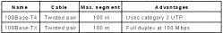
⬥
Cabling
  - Full Duplex
- A station can send and receive simultaneously.
Video-on-Demand - Technologies, Systems, and Applications | 81
2.5 Network - High-Speed Technologies | Jack Y.B. Lee
- Gigabit Ethernet  An even faster version of 802.3 Ethernet, running at 1000 Mbps (1Gbps ).
 Cabling: Fiber optic or CAT-5 UTP  The good thing about 802.3 series of Ethernet is that they are compatible with each other.
82
- Asynchronous Transfer Mode (ATM)
 Designed to integarte all existing types of
communication networks, including
- Plain Old Telephone Service (POTS)
- Public Switched Data Networks (PSDN)
- Telephone company call management network (SSN7)
- Cable Television Network
- Video-on-Demand Service Network
Video-on-Demand - Technologies, Systems, and Applications | 83
2.5 Network - High-Speed Technologies | Jack Y.B. Lee
- Asynchronous Transfer Mode (ATM)  Basic ATM Technology
- Packet switching with small packets (53 bytes) called cells.
Bytes 5 48
Header
User data
An ATM cell
- Connection-oriented, guarantees in-sequence but not delivery.
- Speeds range from 25Mbps to 622Mbps and further.
- Supports Quality-of-Service (QoS) on a connection.
– Delay, delay jitter, average and peak bandwidth, loss rate, etc.
84
- Asynchronous Transfer Mode (ATM)  The ATM Protocol Stack
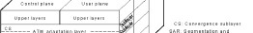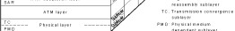
Video-on-Demand - Technologies, Systems, and Applications | 85
2.5 Network - High-Speed Technologies | Jack Y.B. Lee
- Asynchronous Transfer Mode (ATM)  ATM Layer (Network Layer)
- Connection-oriented.
- Use fixed-size (53 bytes) packets called ATM cells.
 ATM Adaptation Layer (Transport Layer, sort of)
- Adds functionalities to provide specific services to different classes of applications.
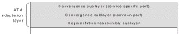
86
- Asynchronous Transfer Mode (ATM)  Types of ATM Adaptation Layer Protocols
- AAL 1, AAL2, AAL 3/4, AAL 5  AAL 1
- Services
  - For real-time, constant bit rate, connection-oriented, stream traffic.
- Applications
  - Such as uncompressed audio and video or
  - A/V compressed using Constant-Bit-Rate (CBR) compression.
- Error Control
  - Notify application of cell loss, no automatic recovery.
Video-on-Demand - Technologies, Systems, and Applications | 87
2.5 Network - High-Speed Technologies | Jack Y.B. Lee
- Asynchronous Transfer Mode (ATM)  AAL 2
- Services
  - For variable-bit-rate, connection-oriented, datagram traffic.
- Applications
  - A/V compressed using Variable-Bit-Rate (CBR) compression.
- Catch!
  - AAL 2 is not usable because the standard does not specify length of header fields.
  - This is intentional(!) because AAL 2 has many problems which cannot be solved in time for standardization.
88
- Asynchronous Transfer Mode (ATM)  AAL 3/4
- Originally two protocols, AAL 3 & AAL 4, for connection-oriented & connection-less services respectively.
- Later merged into a single protocol due to too much overlapping functions.
- Services (2 modes)
  - Supports stream & message, reliable & unreliable delivery.

–
Supports multiplexing:
Video-on-Demand - Technologies, Systems, and Applications | 89
2.5 Network - High-Speed Technologies | Jack Y.B. Lee
- Asynchronous Transfer Mode (ATM)  AAL 5
- History
  - AAL 1 to 3/4 are primary designed by the telecom industry.
  - AAL 5 is designed by the computer industry.
  - Similar to AAL 3/4 but more efficient.
- Services
  - Reliable, non-real-time, with flow control.
  - Unreliable, non-real-time, unicast & multicast.
  - Stream or message modes.
- Applications
  - Transporting IP packets over AAL 5.
90

Part 3 - Systems
- Contents
 3.1 Service Model  3.2 Video Retrieval  3.3 Admission Control  3.4 I/O Bandwidth  3.5 Storage Capacity  3.6 Video Delivery
Video-on-Demand - Technologies, Systems, and Applications 91
3.1 Service Model _{Jack Y.B. Lee}
- What?
 How video data are scheduled for delivery from the
video server to a video client.
- Types of Service Model  Client-Pull v.s. Server Push
Server Client Server Client
Start new video
Video data
Video data
Video data
Video data
Video data
Video data
Video data
.
.
.
Start new video
Request
Video data
Video data
Video data
Video data
.
.
.
Request
.
.
.
Server Push Client Pull
92
3.1 Service Model
- Client-Pull  Advantages
- Simple server design;
- Supports any video bit-rate, CBR and VBR;
- Better tolerance to delay and delay jitter;
- Disadvantages
    - A backward network channel (upstream) from client to server is necessary;
    - More complicated client machine;
    - May requires more buffering at the client.
- Common Applications
• Local Area Networks (LAN) based VoD systems.
Video-on-Demand - Technologies, Systems, and Applications 93
3.1 Service Model _{Jack Y.B. Lee}
- Server-Push  Advantages
- A backward network channel (upstream) from client to server is not needed (desirable in certain applications like satellite broadcast);
- May requires less buffering at the client;
- More predictable performance;
- Easier to optimize server performance.
 Disadvantages
  - Requires real-time hardware and software at the server;
  - Difficult to support mixed bit-rate and VBR videos;
  - Less tolerance to delay and delay jitter;  Common Applications
  - All kinds of VoD systems, particularly WAN-based and satellite video broadcast.
94
  - The Bandwidth Landscape:
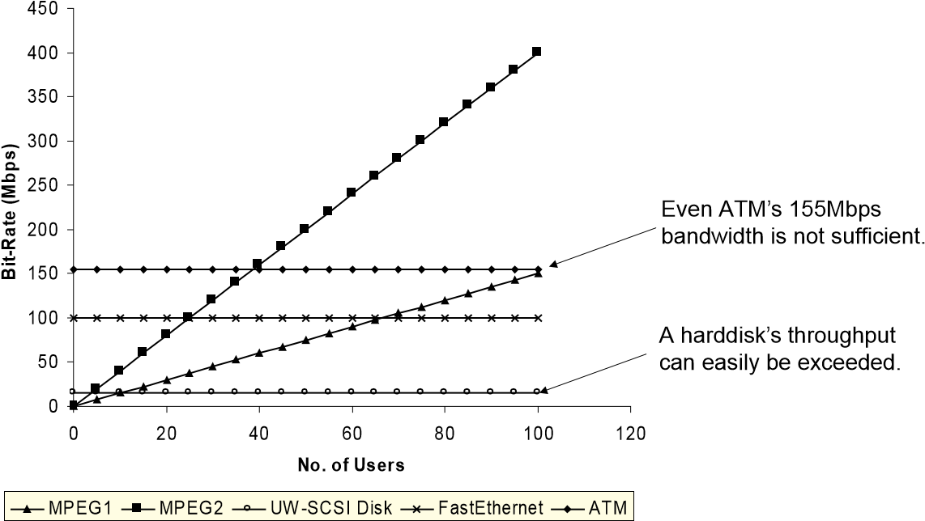
Video-on-Demand - Technologies, Systems, and Applications 95
3.2 Video Retrieval _{Jack Y.B. Lee}
- Single-Stream Retrieval
read
send
Network
 Ideal Disk (Constant Service Time)
Constant delay: d_{i} = d_{j} ∀i , j
time
d
i
d
i+1
d
i+2
d
i+3
d
i+4
d
i+5
Send
Read
Playback
i i+1 i+2 i+3 i+4 i+5
i i+1 i+2 i+3 i+4 i+5
Assumes zero transmission time in network.
96

- Single-Stream Retrieval  In Practice (Variable Service Time)
- Variable delay can cause playback glitches:
time
d
i
d
i+1
d
i+2
d
i+3
d
i+4
d
i+5
Playback
i i+1 i+2 i+3 i+4 i+5
i i+1 i+2 i+3 i+4 i+5
Send
Read
Periodic Playback Intervals
Periodic retrieval Intervals
Video-on-Demand - Technologies, Systems, and Applications 97
3.2 Video Retrieval _{Jack Y.B. Lee}
- Single-Stream Retrieval  In Practice (Variable Service Time)
- Buffering At Server:
time
d
i
d
i+1
d
i+2
d
i+3
d
i+4
d
i+5
Playback
Send
Read
- Buffering At Receiver:
time
d
i
d
i+1
d
i+2
d
i+3
d
i+4
d
i+5
Playback
Send
Read
98
- Multi-Stream Retrieval  One Disk Per Stream
- Simple but wasteful because disk bandwidth is usually much larger than video bit-rate.
- E.g. >10Mbps for HD, but MPEG2 only ~4Mbps.  Multiple Streams Per Disk
- A disk scheduling algorithm is required to ensure that the individual streams will not interfere with each other, and the delay constraint is met.
- There are many disk scheduling algorithms, each with its own strengths and weaknesses.
Video-on-Demand - Technologies, Systems, and Applications 99
3.2 Video Retrieval _{Jack Y.B. Lee}
- Conventional Disk Scheduling Algorithms  First-Come-First-Serve (FCFS)
- Service requests in the order they arrive.
requests Retrieved Data
- Simple but poor disk utilization.
– Example:
Disk Platter
2
1
3
Very long seek time in this example.
100
- Conventional Disk Scheduling Algorithms  SCAN
- Service requests along scanning direction.
requests Retrieved Data
select
- Better disk utilization but potentially long round time.
–
Example:
Disk Platter
2
1
3
4
5
scanning direction
Service Order: 2 5 4 3 1
Note request 1 has to wait longer even it arrives first!
Video-on-Demand - Technologies, Systems, and Applications 101
3.2 Video Retrieval _{Jack Y.B. Lee}
- Multimedia Disk Scheduling Algorithms  Earliest Deadline First (EDF)
- This algorithm schedules the media block with the earliest deadline for retrieval.
- Likely to yield excessive seek time and rotational latency, and poor server-resource utilization can be expected.
 Scan-EDF
  - Same as EDF except using SCAN to schedule requests having the same deadline.
102
  - Disk Scheduling Algorithms for VoD Servers  Characteristic of Continuous Media
  - Periodic retrieval of fixed-size data blocks;
  - The entire retrieval schedule is known beforehand.  Round-Based Disk Scheduling
  - Read one data block for each video stream in each round.
  - Retrievals in a round are serviced using SCAN.
. . .
. . .
Transmission
Retrieval
. . .
. . .
.
.
.
.
.
.
. . .
. . .
. . .
. . .
one round
Video-on-Demand - Technologies, Systems, and Applications 103
3.2 Video Retrieval _{Jack Y.B. Lee}
- Disk Scheduling Algorithms for VoD Servers  Round-Based Disk Scheduling
- To ensure the continuity of data flow for transmission, we need two buffers per video stream.
- Limitations
    - All video streams must have the same data rate; or
    - The data rate must be an integer multiple of a base data rate.
. . .
. . .
Transmission
Retrieval
. . .
. . .
.
.
.
.
.
.
. . .
. . .
. . .
. . .
Worst-Case (2 rounds)
104

3.3 Admission Control
- Admission Control  Motivation
- A VoD system only have finite capacity. Hence a mechanism must be used to admit and reject users to avoid system overload.  Types of Admission Control Algorithms
- Deterministic
– Worst-case scenarios are used to guarantee the service of existing users.
- Statistical
– Statistical behaviors of the system are used to provide probabilistic guarantee. E.g. meeting deadline 99% of the time.
- Observational
– Current system status like utilizations are used to evaluate the admission of new users.
Video-on-Demand - Technologies, Systems, and Applications 105
3.3 Admission Control _{Jack Y.B. Lee}
- Dealing with Missed Deadlines  Why?
- Deadlines could be missed if the admission control algorithm is statistical or some other unexpected events occur.  What to do?
- Ignore It
    - Causes service degradations such as jerky video, decoding error, scrambled video, audio clicks, etc.
    - Depends on how much and what kind of data is missed.
- Error Concealment
    - Repeating data (previous frame, audio packet, etc.)
    - Skipping video frame
    - Lower the resolution (temporary)
106
- Increasing Disk Throughput  Background
- A single disk's through can serve a very limited number of concurrent users.
- For example, a SCSI harddisk can serve around 10
MPEG1 video streams and 3~4 MPEG2 video streams.
 Replication
  - Use multiple disks, each carry a separate copy of a movie.
  - Expensive since movie is large in size.
Moive A,B,C 10 Users
Moive A,B,C 10 Users
Moive A,B,C 10 Users
Video-on-Demand - Technologies, Systems, and Applications 107
3.4 I/O Bandwidth _{Jack Y.B. Lee}
- Increasing Disk Throughput  Partition
- Use multiple disks, each carry different movie titles.
Moive A 10 Users
Moive B 10 Users
Moive C 10 Users
- Same total storage but poor load-balancing.
Moive A 11 Users (Overloaded )
Moive B 2 Users
Moive C 3 Users
108
- Increasing Disk Throughput  Disk Striping (Disk Array)
- Divides a video stream into units and distributes over all
disks in the array.
30
Users
Movie A
b
1
b
2
D
0
b
0
D
1
D
2
b
4
b
5
b
3
b
7
b
8
b
6
b
10
b
11
b
9
B
0
B
1
B
2
B
3
b
13
b
14
b
12
B
4
Data Organization:
Video-on-Demand - Technologies, Systems, and Applications 109
3.4 I/O Bandwidth _{Jack Y.B. Lee}
- Increasing Disk Throughput  Disk Striping (Disk Array)
- One logical stripe is retrieved per stream per round.
b
1
b
2
D
0
b
0
D
1
D
2
b
4
b
5
b
3
b
7
b
8
b
6
b
10
b
11
b
9
B
0
B
1
B
2
B
3
b
13
b
14
b
12
B
4
One logical stripe
- Hence the throughput is N times those of a single disk if there are N disks in the array.
- The disks are spindle synchronized.
110
- Increasing Disk Throughput  Disk Interleaving
- Same as disk striping except one logical unit is retrieved from one of the disk per stream per round.
b
1
b
2
D
0
b
0
D
1
D
2
b
4
b
5
b
3
b
7
b
8
b
6
b
10
b
11
b
9
B
0
B
1
B
2
B
3
b
13
b
14
b
12
B
4
One logical unit
of a disk
- Hence each disk can serve a different stream at the same time, or multiple streams are served concurrently.
- The disks are not spindle synchronized and operates independently.
Video-on-Demand - Technologies, Systems, and Applications 111
3.5 Storage Capacity _{Jack Y.B. Lee}
- Tertiary Storage and Storage Hierarchies  Motivation
- While magnetic disks are suitable for use in VoD systems due to the high throughput and low latency, they are still expensive.
- For applications like video library where large number of videos must be archived, storing all video in disks will become prohibitively expensive (and unnecessary).  Tertiary Storage
Capacity | 9GB | 200GB | 500GB | 10 TB
Mount time | None | 20 secs | 60 secs | 90 secs
Transfer Rate | 2MBps | 300KBps | 100KBps | 1 MBps
Cost | $5,000 | $50,000 | $50,000 | $0.5M to $1M
Cost/GB | $555 | $125 | $100 | $50
Feature Magnetic Disk Optical Disk Low-end Tape High-end Tape
112

3.5 Storage Capacity
- Tertiary Storage and Storage Hierarchies  Tertiary Storage
- Pros
– Removable media like optical disks and tapes are less expensive in terms of cost per GB.
- Cons
    - Lower data transfer rate;
    - Very long random access time.
 Storage Hierarchy
  - Combines the cost-effectiveness of tertiary storage with the performance of magnetic disks.
  - Tertiary storage are used for permanent storage and the magnetic disks used as a cache for video delivery.
Video-on-Demand - Technologies, Systems, and Applications 113
3.5 Storage Capacity _{Jack Y.B. Lee}
- Tertiary Storage and Storage Hierarchies  Storage Hierarchy
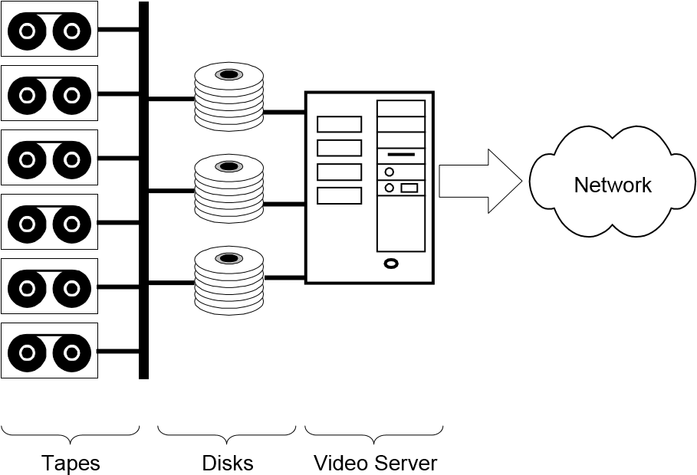
114
3.5 Storage Capacity
- Tertiary Storage and Storage Hierarchies  Storage Hierarchy
- Scheme 1:
    - Store the beginning segments of videos in magnetic disk and the rest in tertiary storage;
    - Starts delivery from magnetic disk while downloading the rest of the video from the tertiary storage.
- Scheme 2:
    - Downloads an entire video from tertiary storage to magnetic disks for delivery.
    - Manage the disk storage using most-recently-used policy.
    - Long startup time for uncached video but the caching should perform well since only a small number of video will be popular at any one time.
Video-on-Demand - Technologies, Systems, and Applications 115
3.6 Video Delivery - LAN _{Jack Y.B. Lee}
- LAN-Based VoD Systems  Characteristics
- Good Points:
    - Cost of network equipment is relatively low;
    - Most hardware and software are off-the-shelve products;
    - Mature and open platforms;
    - Network bandwidth can easily be added;
    - System expansion is easy;
    - Can coexist with existing computer applications.
- Limitations:
    - Geographical span is limited to a few kilometers;
    - Limited user population;
    - More computer oriented (more demanding on the user).
116
3.6 Video Delivery - LAN
- LAN-Based VoD Systems
 Shared Broadcast Networks (Ethernet)
- Very low cost;
- Very limited network capacity;
- Collisions further reduces network throughput;
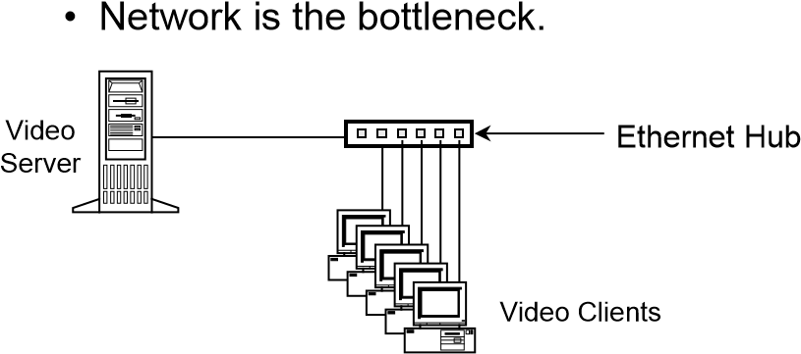
A 10Mbps shared Ethernet segment can support 5~7 MPEG-1 video streams.
Video-on-Demand - Technologies, Systems, and Applications 117
3.6 Video Delivery - LAN _{Jack Y.B. Lee}
- LAN-Based VoD Systems
 Switched Broadcast Networks (Switched Ethernet)
- Each switched-port is independent and has dedicated bandwidth (10Mbps for Ethernet, 100Mbps for FastEthernet);
- More expensive hardware (switch);
- More scalable (i.e. expandable to more users); • Off-the-shelve switches have 2~10Gbps capacity; • Video server is likely to be the bottleneck.
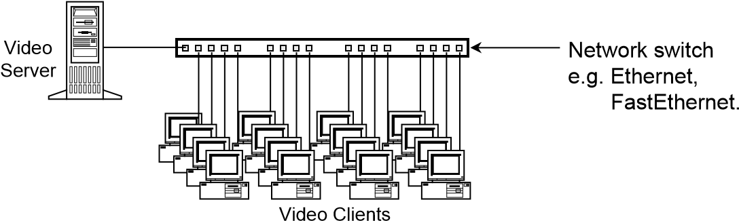
118
3.6 Video Delivery - LAN
- LAN-Based VoD Systems
 Mixed Switched and Shared Broadcast Networks
• More cost-effective than pure switch-based solution.
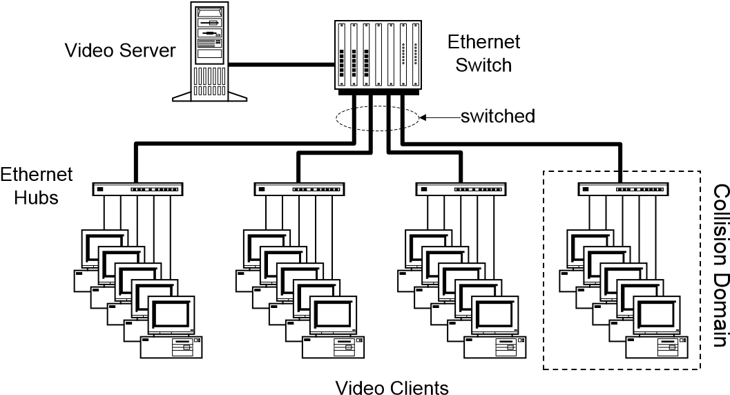
Video-on-Demand - Technologies, Systems, and Applications 119
3.6 Video Delivery - WAN _{Jack Y.B. Lee}
- WAN-Based VoD Systems  Challenges
- Large geographical area;
- Large user population;
- Must coexist with the POTS (Plain Old Telephone System);
- Cost of network equipment is relatively high;
- Network bandwidth is expensive to add;
- Network delay is much higher than LAN;
- Upstream bandwidth is limited;
- A substantial part of the infrastructure is analog.
120

- WAN-Based VoD Systems
 Analog Near Video-on-Demand Approach
NVoD
Server
MUX
RF Mod
Set-top box
TV
Set-top box
TV
RF Tuner
Cable Network (Coax)
NVoD Channels
Video-on-Demand - Technologies, Systems, and Applications 121
3.6 Video Delivery - WAN _{Jack Y.B. Lee}
- WAN-Based VoD Systems
 Analog Near Video-on-Demand Approach
- Low-cost
  - Utilizing existing cable network infrastructure;
  - Simple set-top box (just a RF-tuner); – Coexist with broadcast and cable TV channels; – Independent of number of users.
- Limited Interactive Control
  - No reverse path for control signalling (use the phone);
  - Limited number of channels on a cable (a 450Mhz plant using 6Mhz analog channels supports ~70 channels);
  - Not true VoD (e.g. waiting time ~15 minutes);
  - Little or no VCR control;
  - Limited number of movie selections.
122
- WAN-Based VoD Systems
 Hybrid Fiber Coax (HFC) Approach
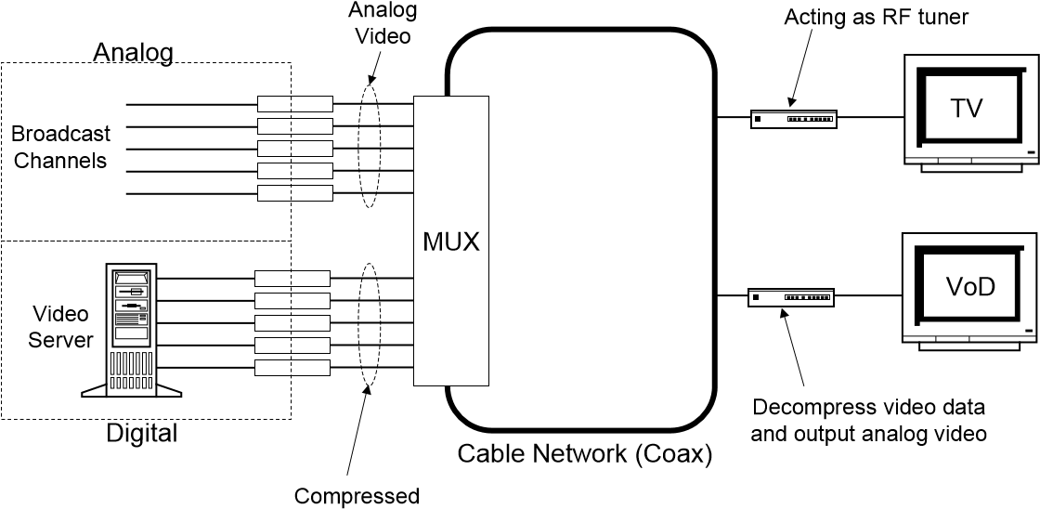
Digital Video Data
Video-on-Demand - Technologies, Systems, and Applications 123
3.6 Video Delivery - WAN Jack Y.B. Lee
- WAN-Based VoD Systems
 Hybrid Fiber Coax (HFC) Approach
- Bandwidth
  - Assume a 750 Mhz cable network;
  - Each 6 Mhz channel can carry 1 analog video channel or
40 Mbps digital data;
– One 6 Mhz channel can carry ~10 MPEG-2 streams;
- Example:
  - Delivers 70 analog video broadcast channels using 450
Mhz;
  - Delivers 500 VoD streams in the remaining 300 Mhz bandwidth.
124
- WAN-Based VoD Systems
 Approaches Using Twisted-Pair Telephone Cables
• Asymmetric Digital Subscriber Line (ADSL)
– ~6 Mbps downstream bandwidth shared by VoD, POTS and ISDN services.
• High-speed Digital Subscriber Line (HDSL)
– 1.544 Mbps full duplex bandwidth.
• Asynchronous Transfer Mode (ATM) – >10 Mbps bandwidth.
Video-on-Demand - Technologies, Systems, and Applications 125
3.6 Video Delivery - WAN _{Jack Y.B. Lee}
- WAN-Based VoD Systems
 Approaches Using Twisted-Pair Telephone Cables
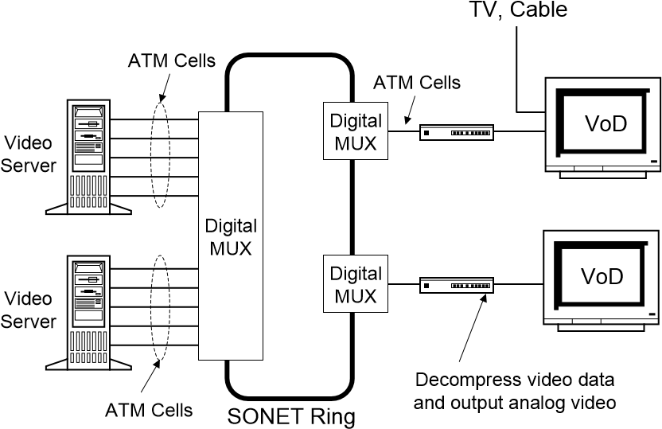
126

Part 4 - Applications
- Contents
 4.1 Entertainment  4.2 Education and Training  4.3 Video Library  4.4 Networked Video Kioks  4.5 Online Commerce
Video-on-Demand - Technologies, Systems, and Applications |  | 127
4.1 Entertainment |  | Jack Y.B. Lee
• | Applications  Movie-on-demand  Karaoke-on-demand  MTV-on-demand
• | System Requirements  Broadcast-quality video  High-quality audio (AC-3, DTS)  Interactive VCR controls  Large user population
• | Suitable Technologies  MPEG-2 compressed video (>3Mbps)   Set-top box type video client  True VoD or good NVoD architecture
128
4.2 Education and Training
- Applications  Video courseware and training  Distance learning and tele-lecturing
- System Requirements
    - Medium to good quality video  Voice-grade audio  Interactive VCR controls  Multimedia content composition, delivery, and
synchronized playback
    - Small user population
Video-on-Demand - Technologies, Systems, and Applications 129
4.2 Education and Training _{Jack Y.B. Lee}
- Suitable Technologies  MPEG-1 compressed video  Computer type video client  True VoD architecture with multimedia support  LAN-based VoD system
130
4.3 Video Library
- Applications  Films and videos archival
- System Requirements
 Broadcast-quality to HDTV-grade video  High-quality audio  Interactive VCR controls  Huge amount of storage (TeraBytes)  Small user population
- Suitable Technologies  MPEG-2 compressed video (>10Mbps for HDTV)
 True VoD architecture  Storage hierarchy (tapes plus disks)  LAN-based VoD system
Video-on-Demand - Technologies, Systems, and Applications 131
4.4 Networked Video Kioks _{Jack Y.B. Lee}
- Applications
 Tourists information kioks at airport  Visitors information kioks at shopping centre, museum,
etc.
- System Requirements
    - Medium to good quality video  Voice-grade audio
    - Interactive VCR controls via touch screen  Multimedia content composition, delivery, and
synchronized playback  Small user population
132
4.4 Networked Video Kioks
- Suitable Technologies  MPEG-1 compressed video  Computer type video client (embedded)
 True VoD architecture with multimedia support  LAN-based VoD system
Video-on-Demand - Technologies, Systems, and Applications 133
4.5 Online Commerce _{Jack Y.B. Lee}
- Applications  Online shopping, banking, marketing, etc.
- System Requirements
    - Good to broadcast quality video  High-quality audio  Interactive VCR controls  Multimedia content composition, delivery, and
synchronized playback
    - Videoconferencing
- Suitable Technologies  MPEG-1 to MPEG-2 compressed video  Set-top box type video client with camera  True VoD with multimedia support
134
Summary
- Technologies
 Server, network, and client technologies are ready;  The cost is still high today for broadcast-quality VoD
applications;
- Systems
 Deployable VoD system solutions are available;  Still lacks a uniform standard across equipment from
different vendors, interoperability is limited;
- Applications  Many existing applications can already be improved by
VoD (e.g. Movie-on-Demand v.s. Movie-Rental);  More and more applications will be benefited when the cost comes down along improvements in hardware and software.
Video-on-Demand - Technologies, Systems, and Applications 135

References Jack Y.B. Lee
• Part of the materials in this workshop is based on:
- R.D.Williams, "Multimedia Networks: Issues and Challenges," IEEE Computer, vol.28(4), April 1995, pp.68-69.
- B.Furht, et al., "Design Issues for Interactive Television Systems," IEEE Computer, vol.28(5), May 1995, pp.25-39.
- A.L.Narasimha Reddy, et al., "I/O Issues in a Multimedia System," IEEE Computer, vol.27(3), March 1994, pp.69-74.
- D.J.Gemmell, "Multimedia Storage Servers: A Tutorial," IEEE Computer, vol.28(5), May 1995, pp.40-49.
- A.S.Tanenbaum, Computer Networks, 3rd Edition, Prentice-Hall, 1996.
- S.V.Raghavan & S.K.Tripathi, Networked Multimedia Systems, Prentice-Hall, 1998.
- MPEG Overview by C-Cube Systems, http://www.c-cube.com/technology/mpeg.html.
- MPEG Audio Introduction by David Renelt, http://www.raum.com/mpeg/introduction.html.
136

